|  |  |
| --- | --- |
| IoT Digital Signage  Installation Guide | Abstract  Remotely create, send, and display messages to televisions or other HDMI supported gadgets anywhere within your enterprise Wi-Fi network. Scheduling, targeting and managing your Playlists on your gadget kiosks are made easy. |

Table of Contents

1. Introduction 2

1.1. Purpose of this document 2

2. Pre-requisites 2

3. Installation Process 2

Document History

|  |  |  |
| --- | --- | --- |
| **Date** | **Version** | **Particulars** |
| 03/16/2018 | 1.0 | Created Installation guide |

# Introduction

The Digital Signage application helps to develop a digital signage content management application with customer interaction. A smart Digital Signage Stick (OEM) communicates with platform and the signage content is displayed remotely from the content manager application. The digital signage content is controlled and monitored centrally by the content manager application.

Digital signage are displays which use technologies such as LCD, LED and projection to display content such as digital images, videos, streaming media, web pages, weather data, restaurant menu, or text. They can be found in public spaces, transportation systems, stadiums, retail stores, hotels, restaurants, and corporate buildings and so on to provide outdoor advertising.

## Purpose of this document

The purpose of this document is to help you to install the Digital Signage application. This is a Stick Provisioning Guide.

## Pre-requisites

Pre-requisites for Digital Signage application:

## Installation Process

To install the Digital Signage application:

1. Please ensure that the Internet connectivity is available.
2. Download the installers from the cloud storage/GitHub location.

1. Extract the DigitalSignage.zip file under C:\ drive.
2. Install the .net 4.6.2 framework. It is a pre-requisite for Digital Signage

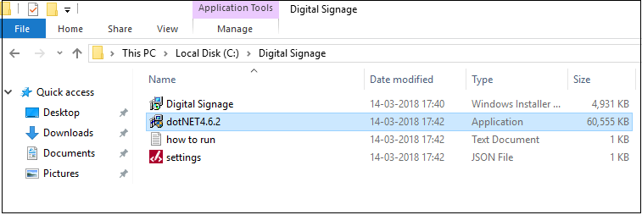

1. Create **"C:/Signage/config"** folder in the C: drive.
2. Paste the **Settings.json** file in this folder, which was created in step 5.

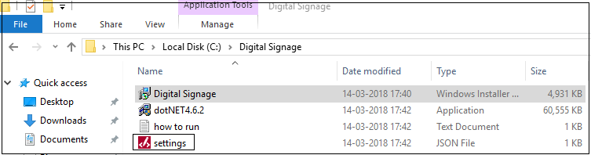

1. Right click the **Settings.json** file and Open with Notepad. Edit the highlighted values to point to the correct **DPS & NodeServerUrl**

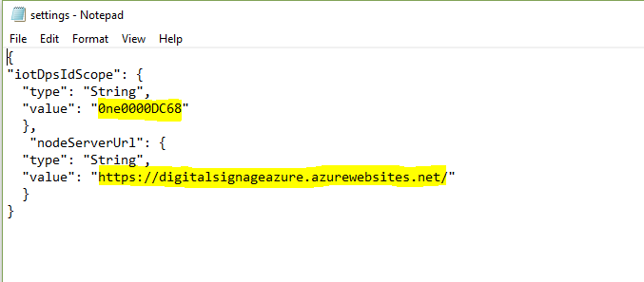

1. Now Double-click the “Digital Signage” installer. Follow the step-by-step installation process. Click **Run Anyway**.

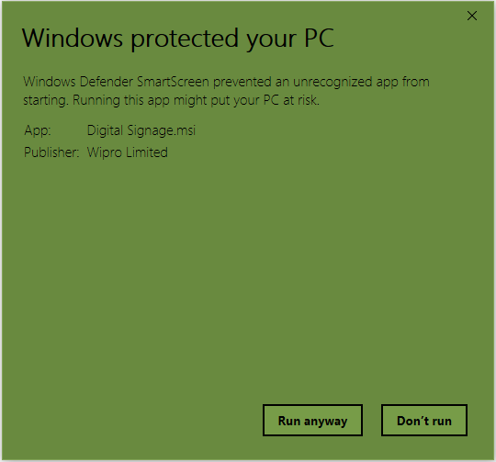

1. Follow the step by step installer

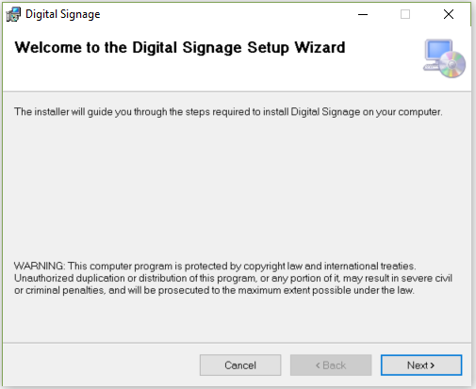

1. **Browse** and select the folder where you want the application to be installed on your system, Click **Next.**
2. Click **Just me** radio button.

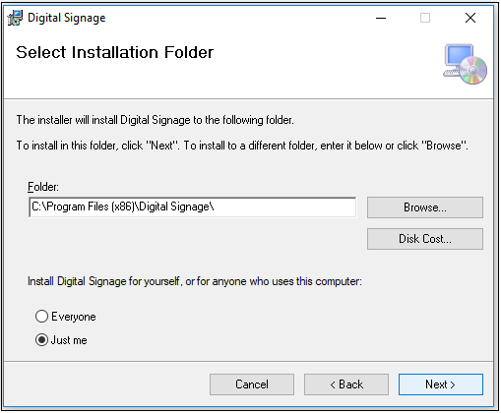

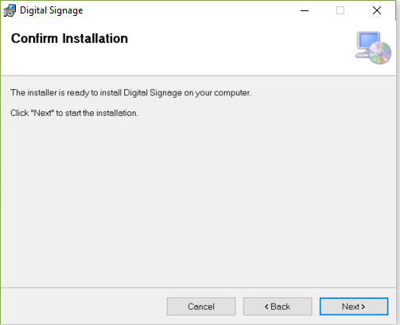

1. After installing browse for installed location of Digital Signage. If the installed location is C:/Program Files then run Startup_prog.bat file as Admin.
2. If installed location is C:/Program Files (x86) then run Startup_progx86.bat file as Admin.
3. After running bat file Digital Signage short cut is created on Desktop.



1. Double click on the icon to launch Application.
2. The application opens and creates a registration in the device.

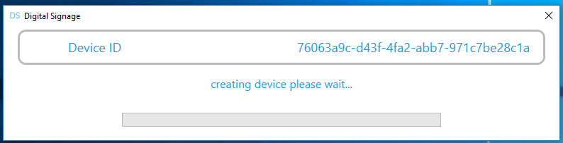

1. After connecting to the network, the application opens.
2. Double-click the Player to show Device ID.

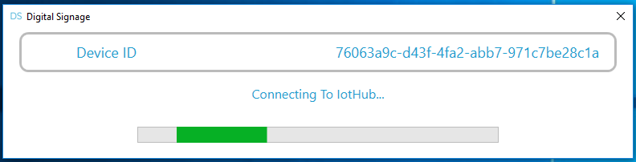

1. Right-click the **Device ID** and copy the device ID to the clipboard. Keep a note of this Device Id as it would be required to register in the Web portal.
2. Double-click the **Device ID** to open player.

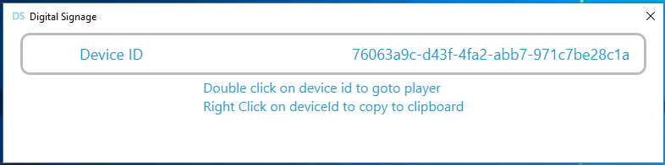

1. The applications open when the windows application restarts.

